الجامعة الإسلامية للتكنولوجيا

UNIVERSITÉ ISLAMIQUE DE TECHNOLOGIE

ISLAMIC UNIVERSITY OF TECHNOLOGY

DHAKA, BANGLADESH

ORGANIZATION OF ISLAMIC COOPERATION



**CSE 4412**

**Data Communication and Networking Lab**

**Lab-02 Report**

**Name :** Tahsin Islam

**Student ID :** 210042137

**Department :** Computer Science and Engineering

**Program :** B.Sc. in Software Engineering

**Semester :** Summer 2022-2023 ( 4th )

**Submission Date :** 30/01/2024

**Task-01**

**Q1: Click Capture/Forward four times. There should be four events in the Event List. Look at the Web Client web browser page. Did anything change?**

**Answer:** Yes, the web browser changed to this:

**Q2: Ensure that the OSI Model tab is selected. Under the Out Layers column, ensure that the Layer 7 box is highlighted. What is the text displayed next to the Layer 7 label? What information is listed in the numbered steps directly below the In Layers and Out Layers boxes?**

**Answer:**

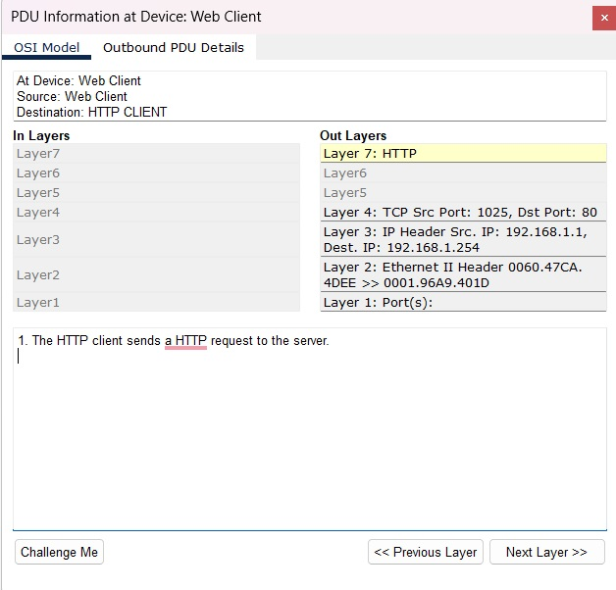

**Q3: Click Next Layer. Layer 4 should be highlighted. What is the Dst Port value?**

**Answer:** Dst port value is 80.

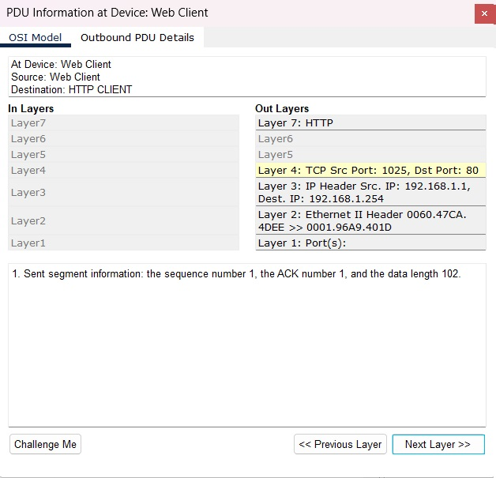

**Q4: Click Next Layer. Layer 3 should be highlighted. What is the Dest. IP value?**

**Answer:** Dest. IP is 192.168.1.254

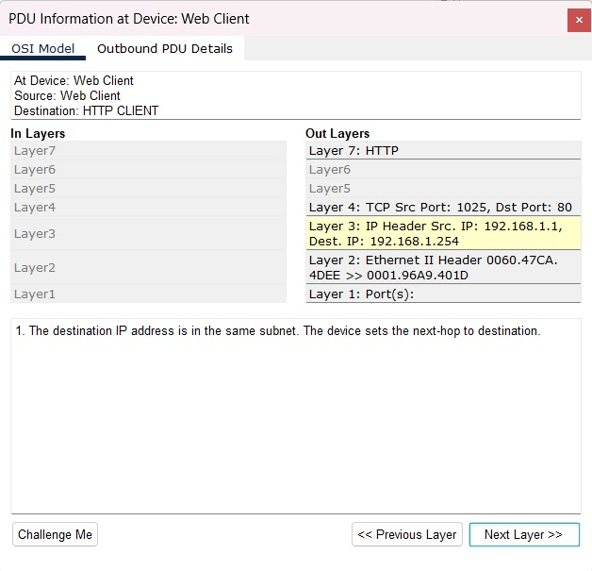

**Q5: Click Next Layer. What information is displayed at this layer?**

**Answer:**

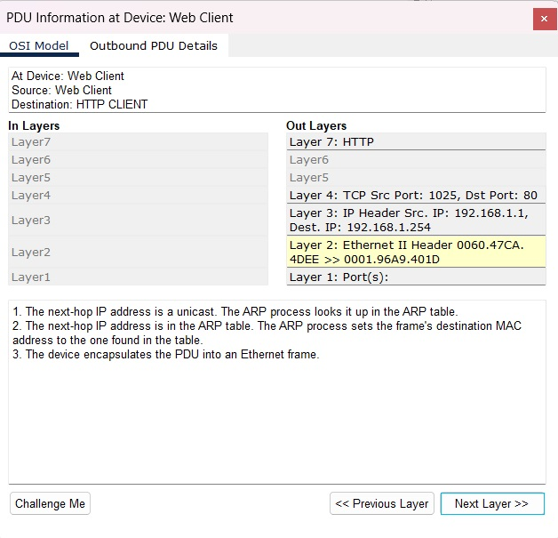

**Q6: What is the common information listed under the IP section of PDU Details as compared to the information listed under the OSI Model tab? With which layer is it associated?**

**Answer:** The common information are source IP address and destination IP address and layer 3 is associated with it.

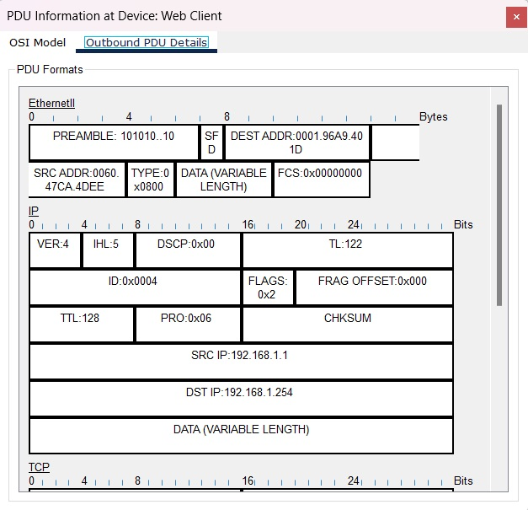

**Q7: What is the common information listed under the TCP section of PDU Details, as compared to the information listed under the OSI Model tab, and with which layer is it associated?**

**Answer:** The common information are source port and destination port and layer 4 is associated with it.

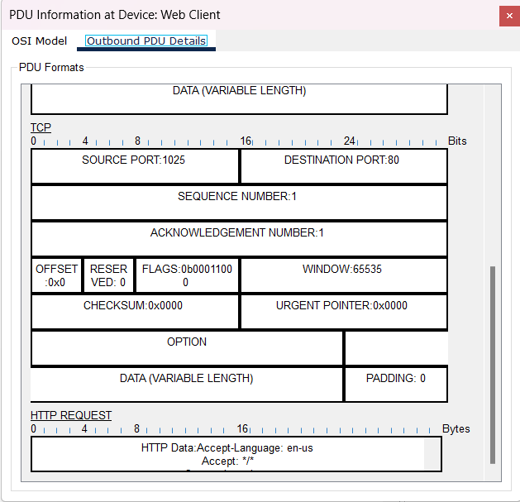

**Q8: What is the Host listed under the HTTP section of the PDU Details? What layer would this information be associated with under the OSI Model tab?**

**Answer:** Host is [www.osi.local](http://www.osi.local). And layer 7 is associated with this.

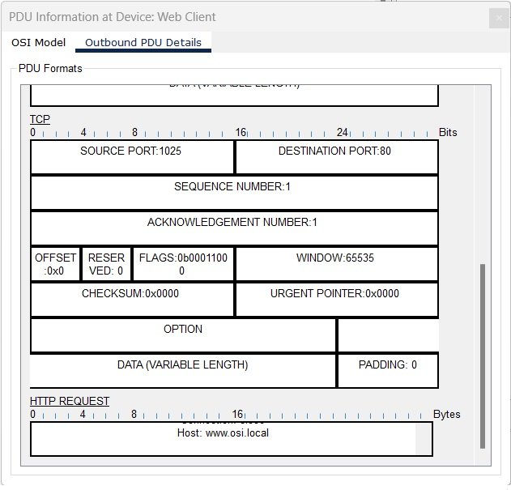

**Q9: Comparing the information displayed in the In Layers column with that of the Out Layers column, what are the major differences?**

**Answer:** We can see that the source IP and destination IP get swapped.

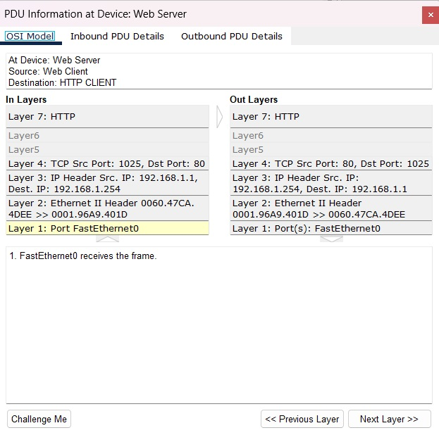

**Q10: What is the first line in the HTTP message that displays?**

**Answer:** HTTP Data:Connection:close

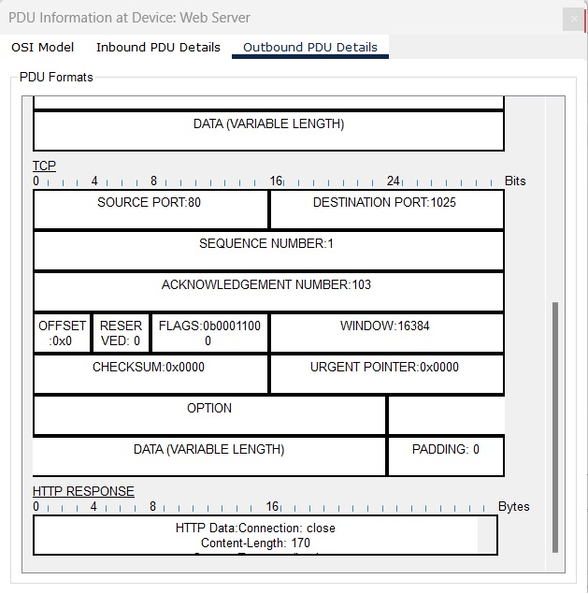

**Q11: How many tabs are displayed with this event and why?**

**Answer:** 2 tabs are displayed in this event. Because the web servers are replayed back web client who receives that.

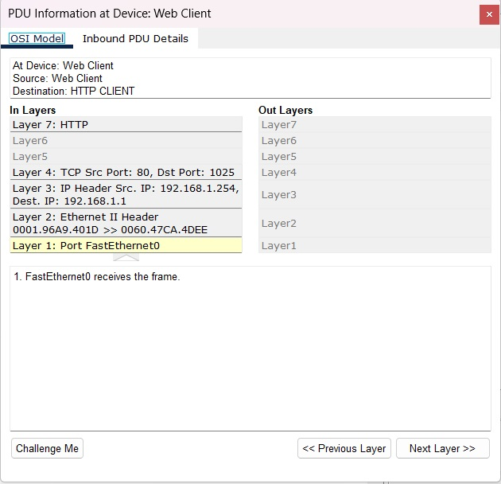

**Q12: What additional Event Types are displayed?**

**Answer:** DNS, ARP, TCP.

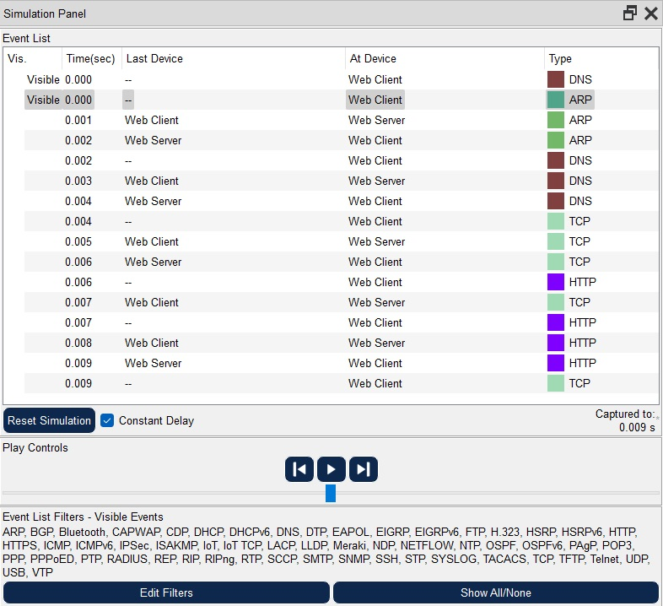

**Q13: Click the Outbound PDU Details tab. What information is listed in the NAME: in the DNS QUERY section?**

**Answer:** Name – [www.osi.local](http://www.osi.local)

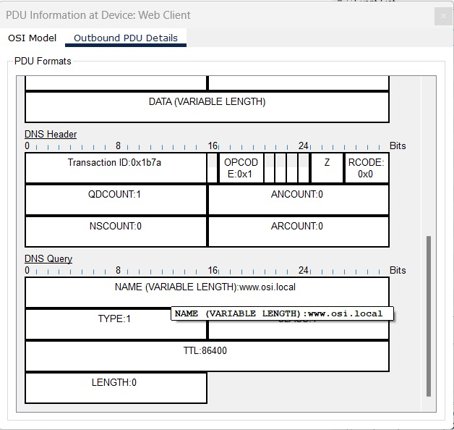

**Q14: Click the last DNS Info colored square box in the event list. Which device is displayed?**

**Answer:** Device – Web client.

**Q15: What is the value listed next to ADDRESS: in the DNS ANSWER section of the Inbound PDU Details?**

**Answer:** 192.168.1.254

**Q16: Find the first HTTP event in the list and click the colored square box of the TCP event immediately following this event. Highlight Layer 4 in the OSI Model tab. In the numbered list directly below the In Layers and Out Layers, what is the information displayed under items 4 and 5?**

**Answer:**

Q17: Click the last TCP event. Highlight Layer 4 in the OSI Model tab. Examine the steps listed directly below In Layers and Out Layers. What is the purpose of this event, based on the information provided in the last item in the list (should be item 4)?

Answer:

**Q18: Based on the information that was inspected during the Packet Tracer capture, what port number is the Web Server listening on for the web request?**

**Answer:** 80

**Q19: What port is the Web Server listening on for a DNS request?**

**Answer:** 53

**Task-02**

**Step 1: Set the IP address**

As I can connect a maximum of 25 hosts per network, in the last octet of the Subnet we will need 5 bits for the host address (25=32), and the first 3 bits of the last octet will be part of the network address.

**Subnet:** 255.255.255.224

**IP range of the first subnetwork:** 192.168.137.1 – 192.168.137.32

**IP range of the second subnetwork:** 192.168.137.33 – 192.168.137.64

**IP range of the third subnetwork:** 192.168.137.65 – 192.168.137.96

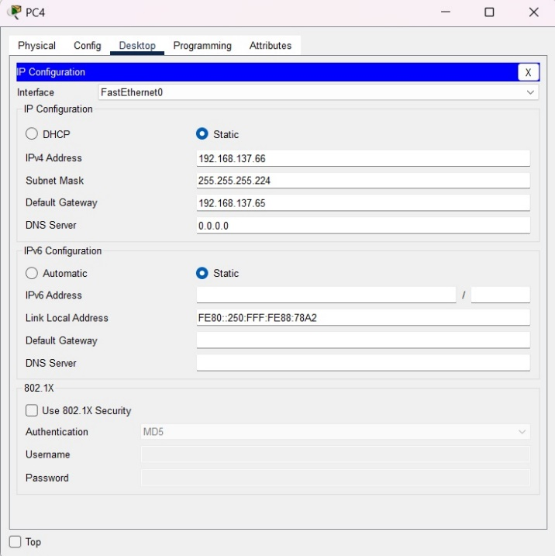

**Step 2: Router Configuration**

To configure the router, I clicked on the router and went to CLI. Ther used the following commands:

|  |
| --- |
| Hostname# enable  Hostname# config t  Hostname(config)# interface gigabitEthernet 0/0  Hostname(config-if)# ip address 196.168.137.1 255.255.255.224  Hostname(config-if)# no shutdown  Hostname(config-if)# exit  Hostname(config)# interface gigabitEthernet 0/1  Hostname(config-if)# ip address 196.168.137.33 255.255.255.224  Hostname(config-if)# no shutdown  Hostname(config-if)# exit  Hostname(config)# interface gigabitEthernet 0/2  Hostname(config-if)# ip address 196.168.137.65 255.255.255.224  Hostname(config-if)# no shutdown  Hostname(config-if)# exit |

Here is the screenshot of the commands:

**Step 4: Using the ping command from the terminal**

To ping, I clicked on PC0, went to Desktop, then Command Prompt. In the command prompt, I wrote:

|  |
| --- |
| Ping 192.168.137.34 |

Here is the screenshot of this step:

We can see that 4 packets were sent and 4 packets were received, 0 packets were lost.